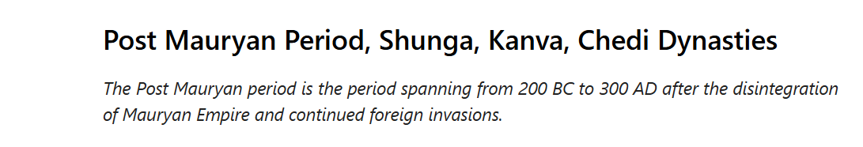

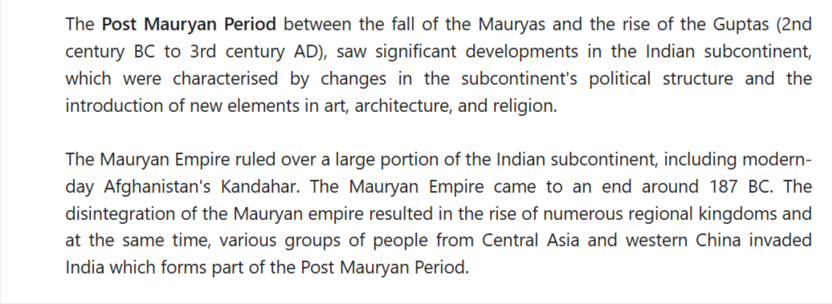

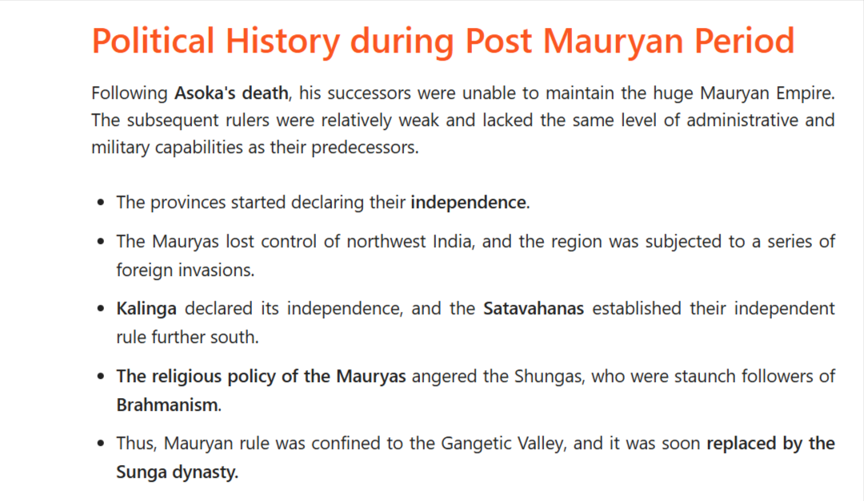

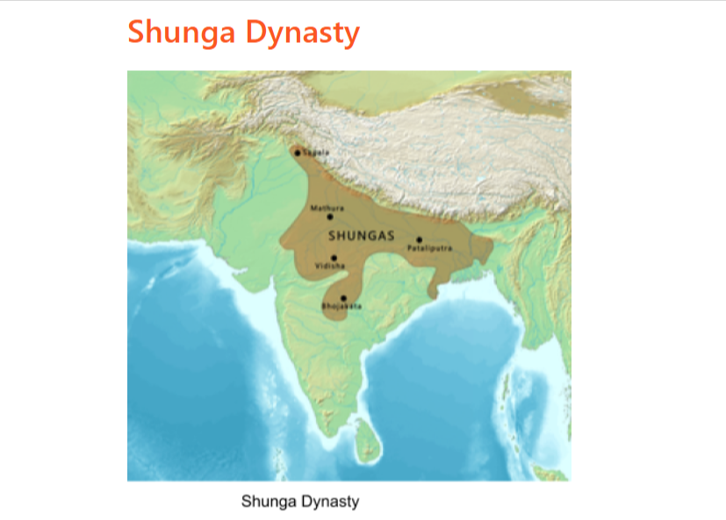

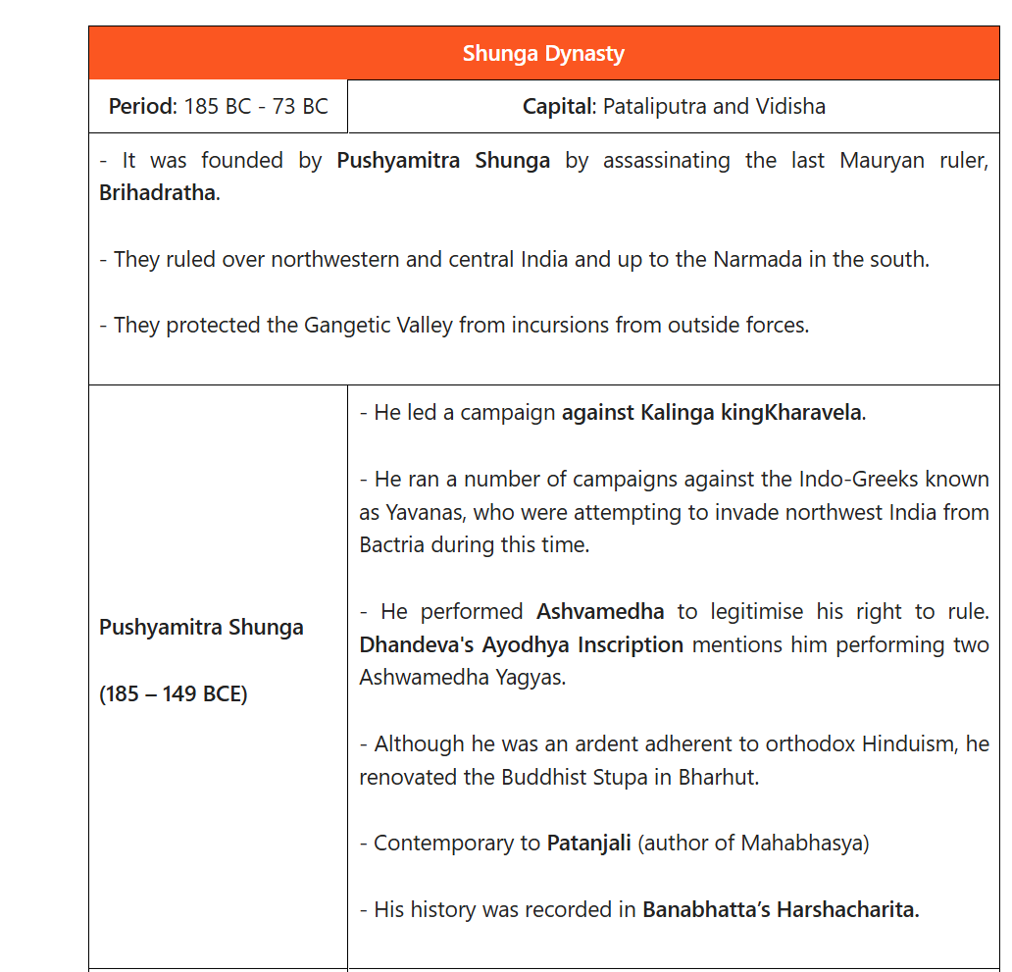

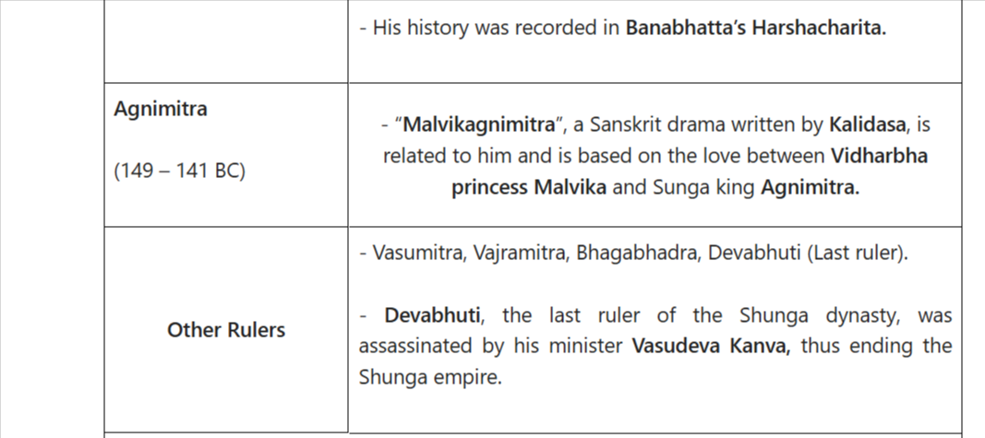

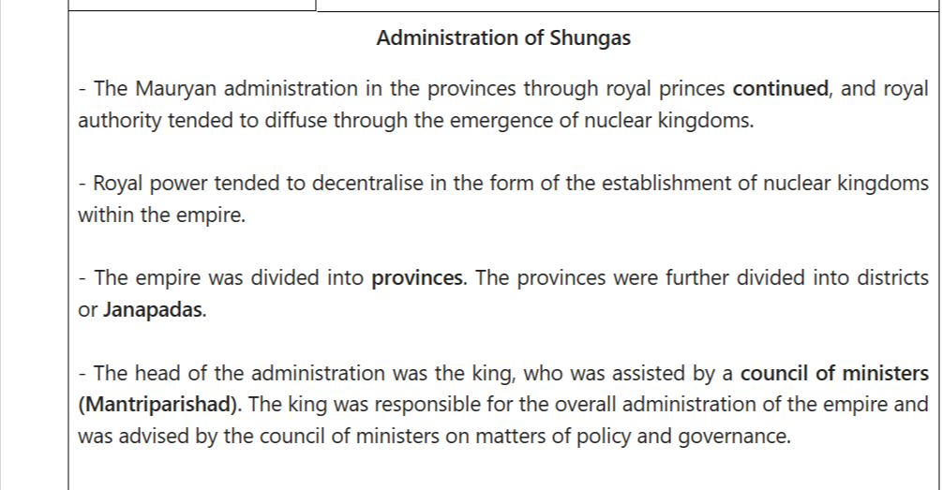

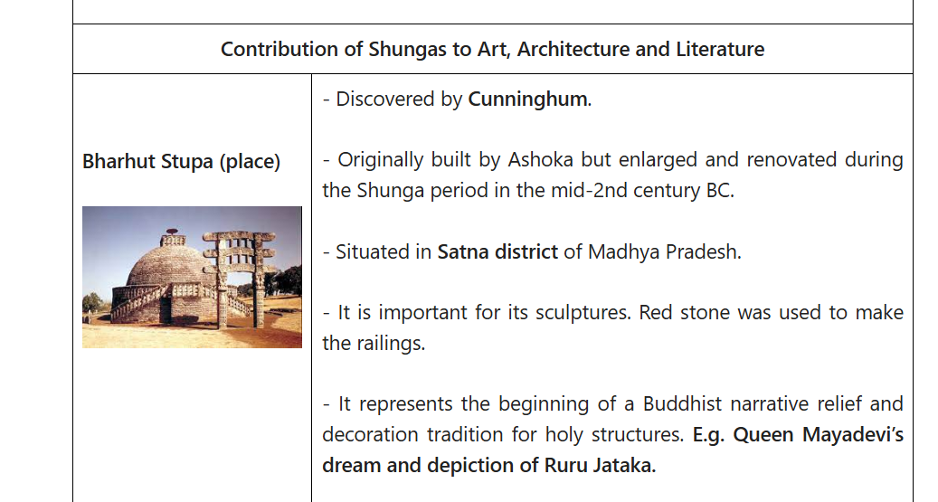

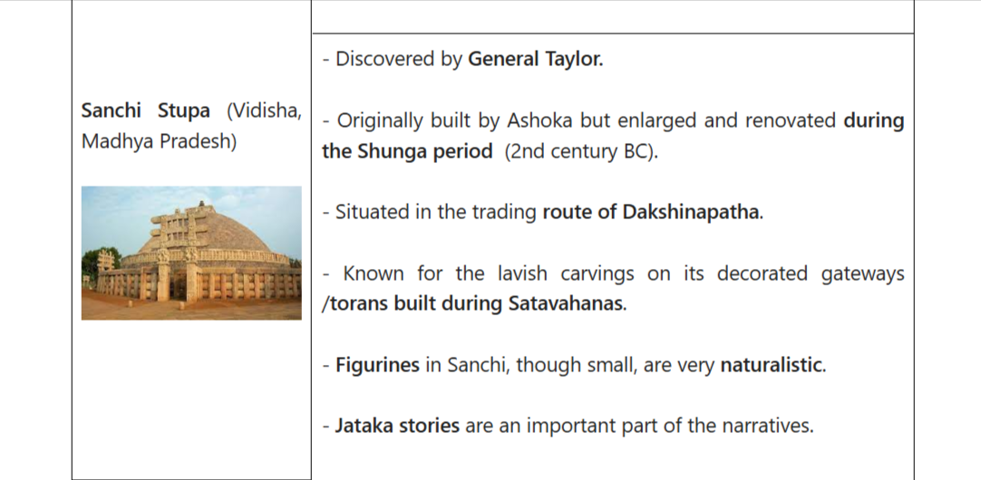

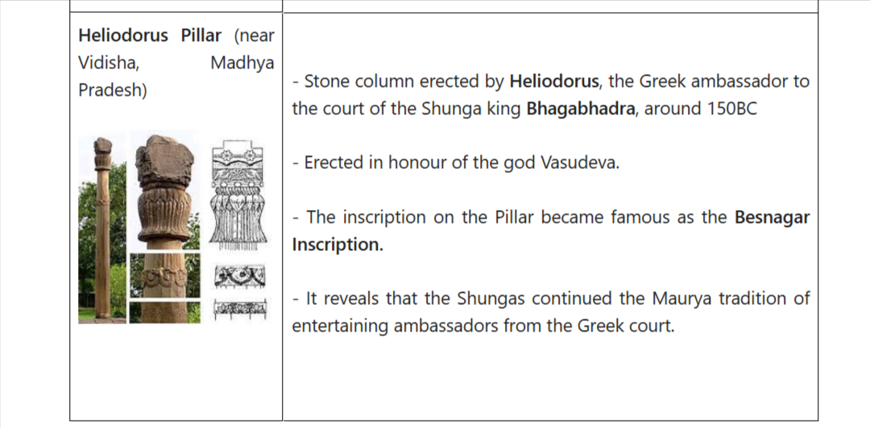

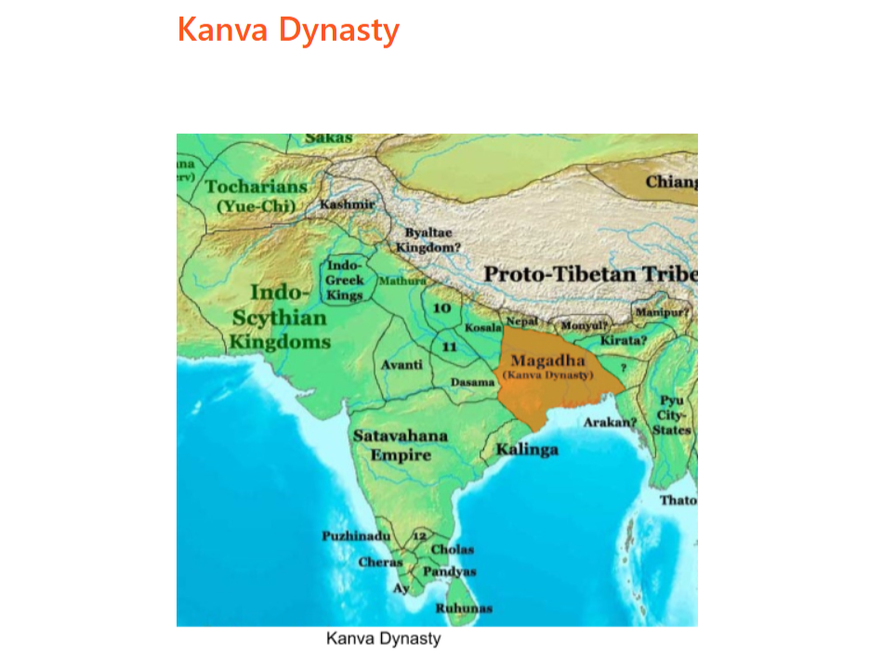

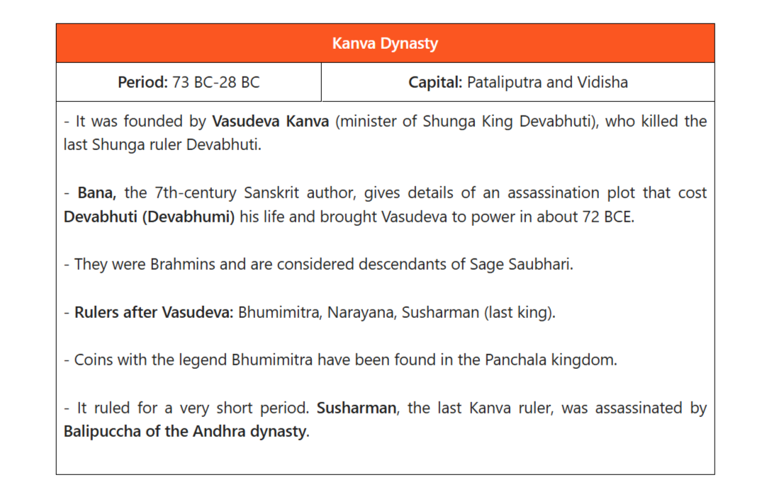

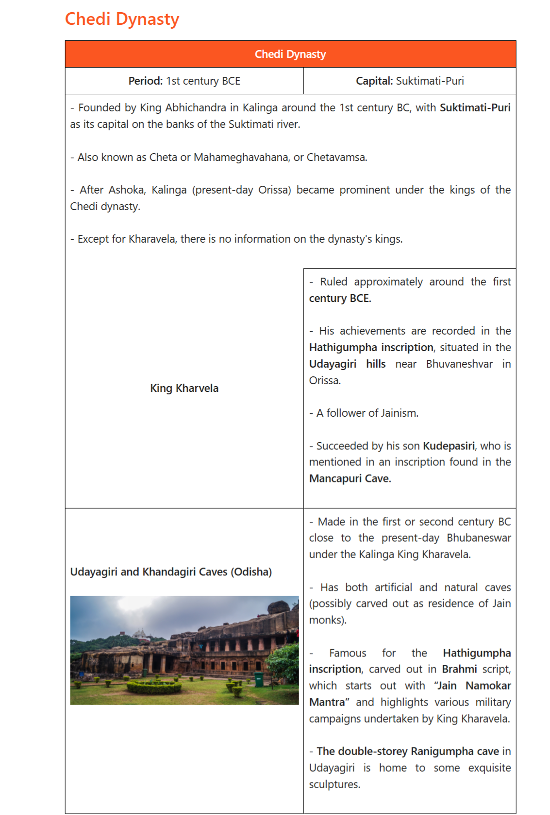

Art and Architecture of Post Mauryan Period
The art of the Post Mauryan Period started reflecting the changing socio-political scenario as well. The architecture of rock-cut caves and stupas proceeded, with each dynasty introducing its own distinctive features. Similarly, various schools of sculpture arose, and the art of sculpture reached its pinnacle in the post-Mauryan period.

Development of Stupas: Stupas are Buddhist commemorative monuments usually housing sacred relics associated with the Buddha or other saintly persons.
Three prominent stupas from this period can be found in Bharhut and Sanchi (both in Madhya Pradesh), which were originally constructed by Ashoka but later expanded, as well as Amravati and Nagarjunkonda (both in Andhra Pradesh).
Stupas became larger and more decorative in the Post Mauryan period. Stone was increasingly used in place of wood and brick.
The Shunga dynasty introduced the idea of torans as beautifully decorated gateways to the stupas.
Early Temples Architecture:
During this time, Brahmanical temples and images of gods began to be built.
Myths mentioned in the Puranas were incorporated into the narrative representation of Brahmanical religion.
Temples were decorated with the images of gods.Each temple had an image of a Chief Deity. These temples are basic structures that include a hall, a veranda, and a shrine in the back.
Important temple sites of this period: Deogarh in Uttar Pradesh, Eran, Nachna-Kuthara and Udayagiri near Vidisha in Madhya Pradesh.
There were three types of temple shrines: Sandhara type (without pradikshinapatha), Nirandhara type (with pradakshina patha) and Sarvatobhadra (accessible from all sides).

‹›
Religion and Society of Post-Mauryan Period
Religion and society during the post-Mauryan period witnessed the following changes.

Rise of Brahmanism: People in the post-Mauryan period practised Vedic religion, Buddhism, and Jainism. However, Brahmanism experienced a resurgence under Shunga's rule. There was an increase in rituals such as Ashwamedha and Rajasuya.
Stories of Pushyamitra's brutality and hostility against Buddhism are described in the Divyavadana.
Varna system: During the post-Mauryan period, the four-fold varna system was also revived. Thus, the social structure became rigid as the fourfold varna system was strengthened. The dominance of priests and the ruling class was strengthened, while the conditions of Shudras remained unchanged.
Position of women: Women's position in society was generally limited to domestic roles, and they were expected to follow strict codes of conduct as mentioned in the Manusmriti.
Cultural expanse: It was the period of the emergence of various mixed castes and the integration of foreigners into Indian society.
Don't miss Vajiram & Ravi updates:

Add Vajiram & Ravi as a preferred source on Google

Add
Language and Literature of the Post-Mauryan Period
The Post-Mauryan period was significant for the development of Sanskrit for religious, philosophical, and literary works.

Sanskrit became more popular during this period and was used to write Buddhist texts also.
Patanjali: His important works include: Yoga Sutras (a collection of Sanskrit sutras (aphorisms) on the theory and practice of yoga), Mahabhasya (an ancient treatise on Sanskrit grammar and linguistics) and Patanjali Tantra (medical text).
The Sanskrit language was written using the variant version of Brahmi script. It is believed that the writing serves as a link between the Kalinga Brahmi script and the Maurya script.
Trade and Commerce in Post Mauryan Period
The Post Mauryan period witnessed the flourishment of commerce and crafts in ancient India and the growth of internal and external trade and commerce.

Craft and commerce:Jyestha was the head of the guild of artisans. Mathura was famous for the production of shataka, a unique kind of cloth.
Merchant class: During this period, trade flourished and resulted in the rise of many types of merchant guilds.
Shreshti led the merchant guild (shreni), while Sarthavaha led the sartha (mobile or caravan trading corporation). Vanijgramo was the head of the corporation of merchants.
Trade routes:
Uttarapatha was the internal trade land route connecting northern and eastern parts of India with the northwestern areas.
Dakshinapatha was the trade land route connecting peninsular India with the western and northern parts of India.
Discovery of monsoon: Discovery of monsoon led to the development of external trade.
Export of spices to the Romans and import of gold and silver from Romans was common.
Around the same time, 200 BCE, there were invasions from Central Asia and western China. Among these were the Indo-Greeks, Scythians or Shakas, Parthiansor Pahlavas, and Kushanas. These invasions not only altered the political structure of northwestern India but also contributed to the transmission and transformation of cultural elements from both India and the Central Asian region.... Read more at: https://vajiramandravi.com/upsc-exam/post-mauryan-period/

FAQs on Post Mauryan Period
Q1. What is the Post Mauryan period?-

Ans. India's Post-Mauryan period was a historical period that came after the collapse of the Mauryan Empire. It started around 200 BCE and lasted until the rise of the Gupta Empire in the fourth century CE.

Q2. What was the Post-Mauryan period known for?-

Ans. It is known for cultural interactions between India and foreign rulers, the spread of Mahayana Buddhism, and the development of three schools of art and sculptures: Gandhara, Mathura and Amravati.

Q3. Who founded the Shunga dynasty, and what were their capital cities?-

Ans. The Shunga dynasty was founded by Pusyamitra Shunga. The capital cities of the Shungas were Pataliputra and Vidisha.

Q4. Who was the famous scholar in the court of Pushyamitra Sunga?-

Ans. Patanjali was a scholar of the Post-Mauryan period. His important works include the Yoga Sutras, Mahabhasya, and Patanjali Tantra. He played a key role in preserving and advancing knowledge.

Q5. What is the significance of the Hathigumpha inscription, and who is associated with it?-

Ans. The Hathigumpha inscription, located in the Udayagiri hills near Bhuvaneshvar, highlights the achievements of King Kharavel. It provides valuable information about his reign and campaign.... Read more at: https://vajiramandravi.com/upsc-exam/post-mauryan-period/

